WORKSHEET 4

SQL

INTERNSHIP 32

FLIP ROBO TECHNOLOGIES



Submitted by: Shahla M

SME : Khushbooo Garg

**Refer the following ERD and answer all the questions in this worksheet. You have to write the queries using MySQL for the required Operation.**

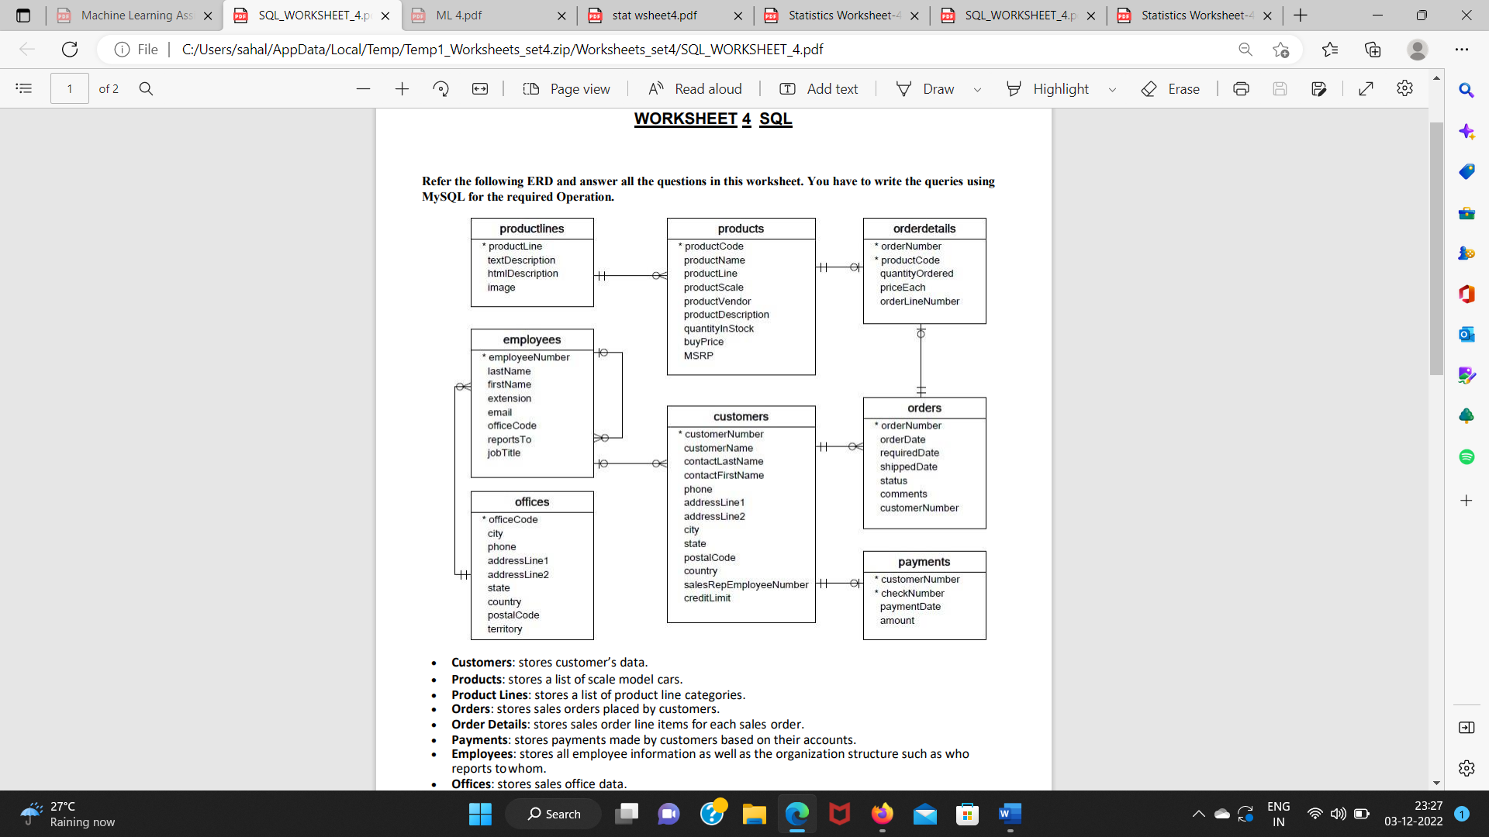

• Customers: stores customer’s data.

• Products: stores a list of scale model cars.

• Product Lines: stores a list of product line categories.

• Orders: stores sales orders placed by customers.

• Order Details: stores sales order line items for each sales order.

• Payments: stores payments made by customers based on their accounts.

• Employees: stores all employee information as well as the organization structure such as who reports to whom.

• Offices: stores sales office data.

1. Write a SQL query to show average number of orders shipped in a day (use Orders table).

ANSWER

Select avg(orderNumber) from order where status="shipped";

1. Write a SQL query to show average number of orders placed in a day.

ANSWER

Select avg from order where orderDate="2008-10-02";

1. Write a SQL query to show the product name with minimum MSRP (use Productstable).

ANSWER

Select productName from products where MSRP=(select MIN(MSRP) from products);

4. Write a SQL query to show the product name with maximum value ofstockQuantity.

ANSWER

Select productName from products where quantityInStock=(select MAX (quantityInStock) from products);

5. Write a query to show the most ordered product Name (the product with maximum number of orders).

ANSWER

Select p.productName from product as p INNER JOIN orderDetails as o on p.productCode=o.productCode where o.quantityOrdered=(select MAX.quantityOrdered);

6. Write a SQL query to show the highest paying customer Name.

ANSWER

Select customerName from customers where creditLimit=(select max(creditLimit) from customers);

7. Write a SQL query to show cutomerNumber, customerName of all the customers who are from Melbourne city.

ANSWER

Select customerNumber, customerName from customer where city="Melbourne";

8. Write a SQL query to show name of all the customers whose name start with “N”.

ANSWER

Select customerName from customers where customerName like "N%";

9. Write a SQL query to show name of all the customers whose phone start with ‘7’ and are from city ‘LasVegas’.

ANSWER

Select customerName from customers where phone like "%7" and city="LasVegas";

10. Write a SQL query to show name of all the customers whose creditLimit < 1000 and city is either “Las Vegas” or ”Nantes” or “Stavern”.

ANSWER

Select customerName from customers where creditLimit < 1000 and city="LasVegas" or "Nantes" or "Stavern";

11. Write a SQL query to show all the orderNumber in which quantity ordered <10.

ANSWER

Select orderNumber from orderDetails where quantityOrdered < 10;

12. Write a SQL query to show all the orderNumber whose customer Name start with letter ‘N’.

ANSWER

Select o.orderNumber from orders as o Inner Join cutomers as c ON c.customerNumber = o.customerNumber where c.customerName like "N%";

13. Write a SQL query to show all the customerName whose orders are “Disputed” in status.

ANSWER

Select CustomerName from orders where status = "Disputed";

14. Write a SQL query to show the customerName who made payment through cheque with checkNumber startingwith H and made payment on “2004-10-19”.

ANSWER

Select c.customerName from customers as c Inner Join payment as p on c.customerNumber = p.customerNumber where p.chequeNumber like "H%" and p.paymentDate = "2004-10-19";

15. Write a SQL query to show all the checkNumber whose amount > 1000.

ANSWER

Select checkNumber from payments where amount > 1000;